Template for Evidence(s)
UI GreenMetric Questionnaire

University : ...
Country : ...
Web Address : …

[6] Education and Research (ED)
SAMPLE

[6.12] Number of activities organized by student organizations related to sustainability per year (ED.5)

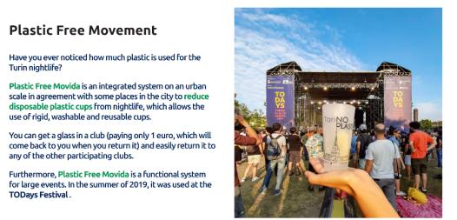
Examples of activities organized by student organizations related to sustainability (Universita degli studi di Torino, Italy)
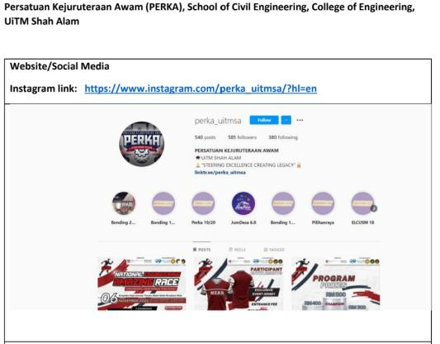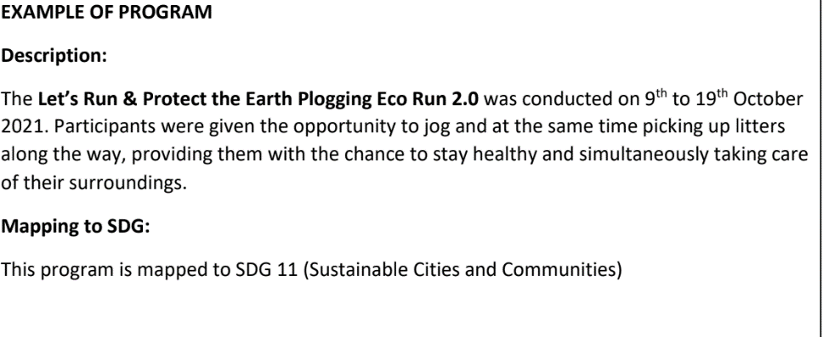
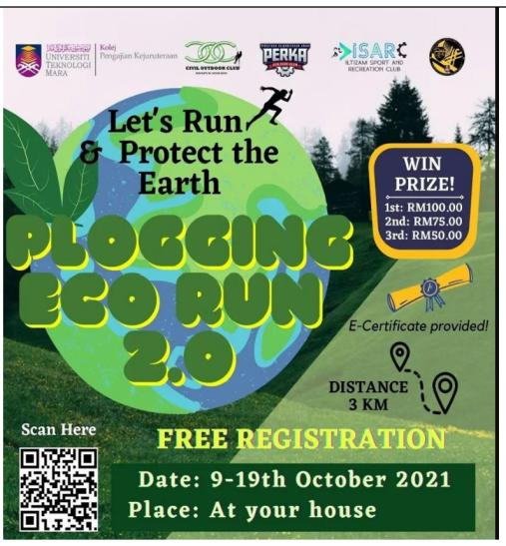
Examples of activities organized by student organizations related to sustainability (UiTM Shah Alam, Malaysia)

Description:
(Please describe activities organized by student organizations related to sustainability on your campus. The following is an example of the description. You can describe more related items if needed.)

Additional evidence link (i.e., for videos, more images, or other files that are not included in this file):
https://greento.it/gruco/

